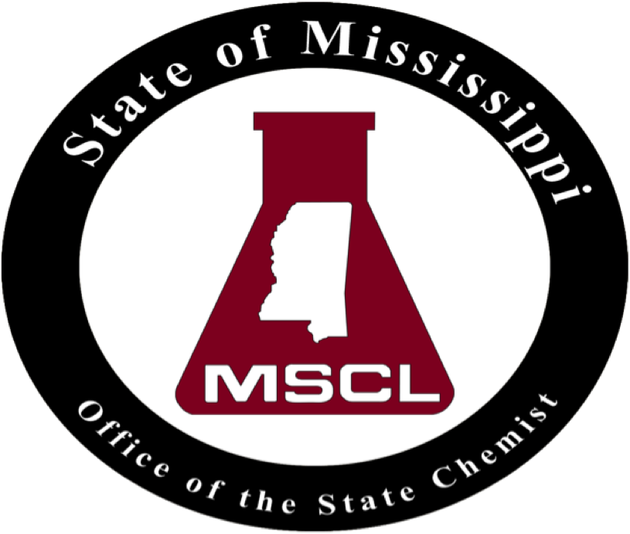
Mississippi State Chemical Laboratory
Dr. Erika Womack, State Chemist
P.O. Box CR • Mississippi State, MS 39762
Phone (662) 325-3324 • Fax (662) 325-7807

May 1, 2025

To Whom It May Concern:

Re: Antifreeze Registration for Period July 1, 2025, to June 30, 2026.

As detailed in § 75-56-9 of the Mississippi Code, any antifreeze or engine coolant must be registered with the State Chemist before July 1st of each year. The Antifreeze Registration application is in the customers section on MSCL’s website: www.mscl.msstate.edu. List the products being registered in the Registration Excel file for submission. Please submit all applications, including supplementary documentation electronically. When submitting a product(s) for registration, you are required to include the completed application form (Excel file), a copy of the label for each product, and a certificate of analysis for each product that provides the basis for the labeled ingredients. If the certificate of analysis is from an independent laboratory, then it is able stand on its merit. However, if the certificate of analysis is from an internal laboratory, then a copy of the accompanying data and testing methods must be provided with the certificate of analysis. If you cannot provide a certificate of analysis for a product(s), then you must also send a one (1) gallon sample of the product with the registration materials so that it can be analyzed to ensure it meets specifications. All registration materials must be received before the product can be registered. Please do not hesitate to contact me if you have any questions.

Sincerely,

Dr. J. Scott Boone
Director of Petroleum Products
Mississippi State Chemical Laboratory
310 Presidents Circle
Mississippi State, MS 39762
sboone@mscl.msstate.edu
Office Phone: 662-325-3324

Enclosure: Antifreeze Registration Form

